**FIVE PEN PC TECHNOLOGY**

Kumar Shanu Anand (1115030)  
Student, School of Computer Science & Engineering  
Kalinga Institute of Industrial Technology.  
[1115030@kiit.ac.in](mailto:1115030@kiit.ac.in)

**Abstract**

*“5 pen technology” is a recent discovery in the field of pen computing. Pen computing is a field that outlines computer like user interface which uses pen like devices that will be convenient to use in comparison to contemporary systems (such as laptops, desktops etc.). 5 Pen PC technology consists of 5 pen like devices which are used for providing functions of a CPU, a projector, a virtual keyboard, a camera, and communication functions of a cellular phone.*

*P- ISM’s are connected with one another through short-range wireless technology. Pen-style Personal Networking Gadget is computers in the shape of different pens each having a function of its own and when combined together give us the usage of a full-blown computer.*

**Keyword**: P-ISM, Pen Computing, CPU Pen, Pen Camera, Virtual Keyboard

CONTENTS

1. **Introduction**

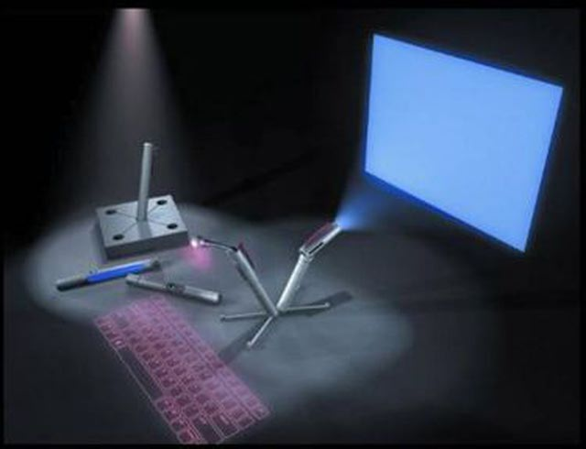

**Fig.1** 5 Pen PC Technology

During the ITU Telecom World exhibition held in 2003, Geneva, the Tokyo-based NEC Corporation presented a conceptual prototype of P-ISM. The FIVE PEN PC technology was designed by Toru Ichihash. It is basically an innovation in the field of computers in association to the communication field. Rest assured, it will have a greater impact in the field of computers.

People often tend to make notes of the important things they come across in the most traditional method used and still in use are pen and paper. On similar but more technical terms, the 5 pen pc technology with digital pen makes it possible to obtain a digital copy of handwritten information, and have it transferred to digital devices via wireless technologies like Bluetooth, which operates as the main interconnecting device between different peripherals. The whole set is also coupled to the Internet which makes the communication even more easy and efficient. With the use of E-fingerprinting the gadget will be more secure, which allows only owner to activate the Pc. So even if we lose it, no one else can access the gadget. All five pen can rest in a holding block which recharges the batteries.

1. **Topic Details**

It consists of 5 pens which serve following functions.

* 1. CPU PEN

This pen functions as a CPU. It is also known as computing engine. The control unit (CU) contains circuitry that uses electrical signals to direct the entire computer system to carry out stored program instruction. The control unit does not execute program instruction; rather, it directs other parts of the system to do so. It has DUAL CORE microprocessor and works with windows XP operating system. The operating system comes preloaded and it cannot be changed. [2]Microprocessors are manufactured on very small number of IC’s. [2]The overall smaller CPU size as a result of being implemented on a single die means faster switching time because of physical factors like decreased gate parasitic capacitance. [2]This has allowed synchronous microprocessors to have clock rates ranging from tens of megahertz to several gigahertzes. [2]Additionally, as the ability to construct exceedingly small transistors on an IC has increased, the complexity and number of transistors in a single CPU has increased dramatically. [2]This widely observed trend is described by Moore's law, which has proven to be a fairly accurate predictor of the growth of CPU (and other IC) complexity to date. It also acts as a central device which connects other pen devices through wireless technology. CPU pen is shown in Fig. 2.

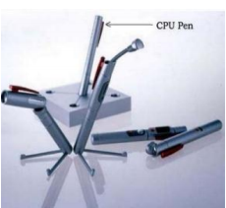

**Fig.2** CPU PEN

* 1. Communication Pen

This pen facilitates communication between all the pens. [2]They are connected through Tri-wireless modes (Blue tooth, 802.11B/G, and terabytes of data, exceeding the capacity of today’s hard disks. [2]This is very effective because we can able to connect whenever we need without having wires. [2]They are used at the frequency band of 2.4 GHz ISM (although they use different access mechanisms).

It has an inbuilt cellular phone function which enables it to connect to the internet. Thus, the entire set can be connected to the internet and the device can perform the entire web related task. [2]Cellular networks offer a number of advantages over alternative solutions such as:

* Increased capacity reduced power use larger coverage area.
* Reduced interference from other signals.

[1]It can also be used as a pointing device which provides functions similar to mouse. Hence, allowing the user to interact with the contents displayed by the projector pen. Communication pen is shown in Fig.3.

Communication Pen.png

**Fig.3** Communication Pen

* 1. Projector Pen

The projector pen works like a conventional projector with maximum display resolution of 1024 X 768 pixels. It provides a high quality picture. But, it should project on a flat surface for better visibility. Its clarity depends on the distance between the projector pen and the screen. Greater the distance between the two less will be the clarity. Also, with increase in the size of image, brightness decreases. Hence, smaller image size helps conserve energy. Projector pen is shown in Fig.4.

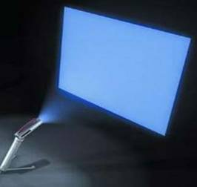

**Fig.4** PROJECTOR PEN

2.4 Digital Camera Pen

Digital camera pen has an inbuilt digital camera which can be used for taking pictures and recording videos. The Camera pen can also be used as a webcam for video conferencing, Skype etc. The camera can rotate full 360˚. This terminal will enable us to know about the surrounding atmosphere and group to group communication with a round display and a central super wide angle camera. Digital Camera is shown in Fig.5.

camera pen.PNG

**Fig. 5** Digital Camera Pen

* 1. Virtual Keyboard (VKB) Pen

This pen functions similar to LED projector pen. It projects LED light on a plane surface to form a QWERTY keyboard i.e. it uses a laser beam to generate a full-size perfectly operating laser keyboard that smoothly connects to of PC and most of the handheld devices. [2]As we type on the laser projection, it analyses what we are typing according to the co-ordinates of the location. A virtual keyboard is a software component that allows a user to enter characters. A virtual keyboard can usually be operated with multiple input devices, which may include a touch screen, an actual keyboard, a computer mouse, a head mouse and an eye mouse. Its functions are similar to the real keyboard or the on screen keyboard.

[2]Another major use for an on-screen keyboard is for bi- or multilingual users who switch frequently between different character sets or alphabets. Although hardware keyboards are available with dual keyboard layouts (for example Cyrillic/Latin letters in various national layouts), the on- screen keyboard provides a handy substitute while working at different stations or on laptops, which seldom come with dual layouts. The standard on-screen keyboard utility on most windowing systems allows hot key switching between layouts from the physical keyboard (typically alt-shift but this is user configurable), simultaneously changing both the hardware and the software keyboard layout. In addition, a symbol in the system tray alerts the user to the currently active layout.

[1]It has following features

1. Timeouts: Time outs to conserve battery life.
2. Sensitivity: Sensitivity of the virtual keyboard can be adjusted.
3. Controllable VKB’s sound effects (key clicks).
4. Intensity: Intensity of the projected keyboard.

Virtual Keyboard pen is shown in Fig.6.

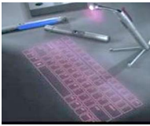

**Fig. 6** Virtual Keyboard Pen

Battery

The most important part in portable type of computer is battery. Usually batteries must be small in size and work for longer time. For normal use it can be used for 6+ days. The type of battery used here is lithium ion battery. The use of lithium ion battery in this gadget will reduce energy density, durability and cost factor.

Storage

[2]The storage device is of the type tubular holographic. [6]It is capable of storing of recording and reading millions of bits in parallel, enabling data transfer rates greater than those attained by traditional optical storage.  Holographic data storage records information throughout the volume of the medium and is capable of recording multiple images in the same area utilizing light at different angles. Holographic data storage can provide companies a method to preserve and archive information. The write-once, read many ([WORM](http://en.wikipedia.org/wiki/Write_Once_Read_Many)) approach to data storage would ensure content security, preventing the information from being overwritten or modified.

Advantage

* It is convenient to use because of its portability.
* It supports wireless technology.
* Excellent battery life of 6+ days (on subtle use may extend to 2 weeks).

Disadvantage

* High cost
* One of the components can easily be misplaced
* Projection surface should be flat for optimum usage.

Future Scope

Currently this device is not available for public use, reason being high cost of production. The prototype developed by the company proves that the creation of such complex technology is feasible, but because of lack of information about its recent developments, it is unclear what the company’s intentions are about this technology. Moreover, the device will be able to make space in the crowd of portable devices.

Its ability to connect with internet will allow the people to avail cloud service. So, people don’t have to worry about storage space. Also, when combined with cloud services such as SAAS, IAAS and PAAS no performance issue occurs.

Use of Holographic memory will help to increase the data storage capacity of the device.

1. **Conclusion**

By making Five Pen PC feasible, it will enable ubiquitous computing therefore it is easier for people to use. Many applications can be imagined with this new technology. As it makes use of E-fingerprinting the gadget will be more secure, which allows only owner to activate the Pc. So even if we lose it, no one else can access the gadget. All PC’s communicate each other with the help of Bluetooth technology and the entire gadget is connected to internet (Wi-Fi). This technology is very portable, feasible and efficient. Everybody can use this technology in very efficient manner. Some prototypes have been already developed in 2003 which are very feasible, but currently unclear. The enhancement in this technology can be expected in coming years.

Use of Holographic memory will increase it storage capacity. Use of E-fingerprinting helps to make the device secure, which allows only the owner to activate the PC. So, even if we lose the PC no one else can access the gadget.

One of the reasons of its success is that it complements the cloud services.**References**

[1]. Nirav Nayani, Shrey Bavisi and Harish Narula,  
*5 Pen PC Technology, International Journal of Current Engineering and Technology, Vol.4, No.5 (Oct 2014)*

[2]*. Mrunal Shidurkar, Mohammad Usman  
International Journal of Scientific & Engineering Research, Volume 4, Issue 12, December-2013*

[3].Pen Computing 2015  
 [*http://en.wikipedia.org/wiki/Pen_computing*](http://en.wikipedia.org/wiki/Pen_computing)

[4].5 Pen PC Technology – SeminarTopics.com   
[*http://www.seminarstopics.com/seminar/5-pen-technology*](http://www.seminarstopics.com/seminar/5-pen-technology)

[5].5 Pen PC Technology (Images)  
[*http://www.slideshare.net/atinav242/5-penpctechnology-complete-ppt*](http://www.slideshare.net/atinav242/5-penpctechnology-complete-ppt)

[6].Holographic Data Storage   
<http://en.wikipedia.org/wiki/Holographic_data_storage>